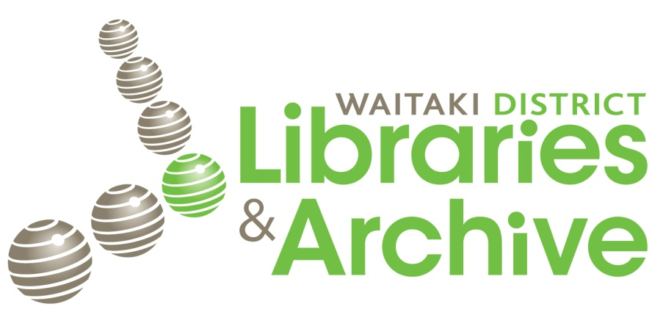

A Guide to the Waitaki District Archive
@ the North Otago Museum

There are two collections available to researchers:

- The Reference Collection which is available during museum opening hours (10:30am to 4:30pm) in the Research Area of the Archive (towards the back of the Museum). The use of this collection does not necessarily involve guidance and supervision by the archivist.

- The Archive Collection which is available during archive opening hours (Monday to Friday, 1 to 4pm) under guidance and supervision of the archivist.

Reference Collection

The Research Area of the Archive is open during Museum opening hours (10:30am to 4:30pm) for members of the public to consult the research collection. Resources available include:
Cemetery information:
- Burial information and headstone transcriptions from the Oamaru cemeteries (Old and Lawn cemetery), 1867 to 2011 (bound volumes).
- Indexed headstone transcriptions and burial records of some of the outlying Waitaki cemeteries, including: Herbert/Otepopo, Maheno, Palmerston, Duntroon.
Birth/Baptism/Marriage/Death indexes and notices:
- Birth, Marriage and Death notices from the Oamaru Mail, 1876 to 1932 (bound volumes).
- Indexed Birth, Baptism, Marriage and Death records of a number of Waitaki churches, mainly Presbyterian and Anglican (folders).
Other genealogical resources:
- A card index (arranged by surname) with references to published sources (newspapers, NZ Gazette, microfiche, local history books) where a person’s name is mentioned.
- A newspaper reference collection (newspaper clippings from local papers) organised by topics in folders. Includes alphabetical folders for surnames, organisations, localities in the Waitaki.
- A range of microfiches which cover New Zealand wide records, including: New Zealand births 1840 to 1990, New Zealand marriages 1840 to 1990, New Zealand cemetery records.
Newspapers:
- Microfilms of local newspapers (Evening Mail, Oamaru Times, North Otago Times, Oamaru Mail) from 1864 to 1953. There is a microfilm reader in the Research room.
Published resources
- A range of published books, booklets and pamphlets relating to the history of the Waitaki region.

Archive Collection

This collection is housed in the purpose-built Archive towards the rear of the Museum and contains archival records relating to the Waitaki District.
We collect, preserve and make available for research:
- The records of present and past local governments of the Waitaki region including: Oamaru Borough Council, Waitaki County Council, Waihemo County Council, Palmerston Borough Council, Waitaki District Council. The records range in date from 1863 to the present. The records include:
- Minute Books
- Rate Books
- Valuation Rolls
- Maps and plans of places and buildings in the Waitaki

- A wide range of local history archives relating to the Waitaki district, including:
- Personal and family papers – such as letters, diaries, research notes
- Business records – for example: Oamaru Woollen Mills, Hislop & Creagh (Law firm), Oamaru Harbour Board
- School records – from a number of local schools
- Records of various clubs and organisations of the Waitaki district
- Oral Histories – interviews conducted with prominent locals
- Photographic collection – over 500,000 photographs of Waitaki people and places

- An almost complete run of local newspapers in print form, including:
- The Oamaru Mail from 1876 to the present
- The North Otago Times from 1864 to 1932

- A collection of books, including:
- Accounts and histories relating to the World Wars
- Histories compiled for various regions, topics and events in the Waitaki

