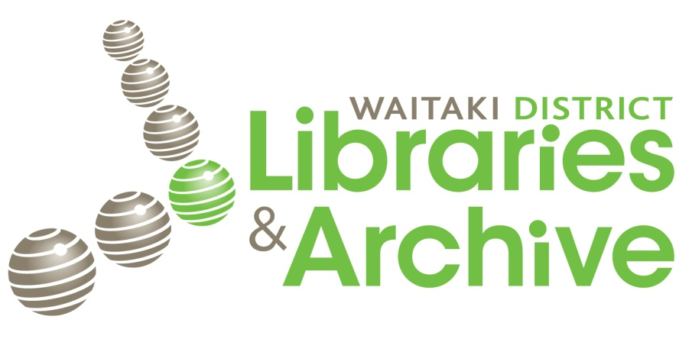
Primary Sources Accessing online & via Waitaki District Libraries & Archive
Some key websites:
Waitaki District Libraries catalogue www.library.waitaki.govt.nz
National Library - Resources for schools- Primary Sources http://schools.natlib.govt.nz/ resources-learning/primary-sources/primary-sources- what-are-they
National Library – Information for- students http://schools.natlib. govt.nz/ information/students
Many Answers http://www.manyanswers.co.nz/
Papers Past http://paperspast.natlib.govt.nz
Digital NZ http://www.digitalnz.org/

